Kantara Document Publication Procedures

Kantara Publication Types 2
Publication Distribution Options 2
Publication Metadata and Required Elements 3
Cover (First) Page Elements 3
Second Page Elements 4
Third Page Elements 4
Document Headers 4
Cover Page Footer 4
Document Footers 4
Notice 6
OPTION: NON-ASSERT COVENANT 6
OPTION: RAND 6
OPTION: CREATIVE COMMONS ATTTRIBUTION-SHARE ALIKE 6
OPTION: APACHE CLA 7
Citation format 8
xml2rfc-style example 8
Kantara-style examples 8
Approval Stages 9
Workflow Diagrams 10
Document Status 12
Work Group Recommendations 13
Work Group Technical Specification Recommendations 14
Work Group Reports 15
Discussion Group Reports 15
Word Template Document Status Automation Notes 16

Kantara Publication Types
There are two major classes of publication at Kantara defined in the Bylaws: Recommendation and Report.
1.21 “Recommendation” shall mean any output of a Work Group (e.g. draft Technical Specification, policy, guidelines, procedures, etc.) that has been approved by a Supermajority of those Voting in an All Member Ballot.
1.22 “Report” shall mean any output of a Work Group or Discussion Group that is not a draft Technical Specification nor a Recommendation (e.g. policy, guidelines, procedures, etc.) that has been approved by a Supermajority of those Voting in an All Member Ballot.
And one sub-type of Recommendation called a Technical Specification:
1.28 “Technical Specification” shall mean a document created by a Work Group that is expressly designated as a “Technical Specification” and that contains detailed technical information of a nature that must be implemented as described therein for an implementation thereof to be deemed compliant. A Work Group Charter shall identify an SSO (or multiple SSOs) to which the Technical Specification should be submitted for consideration for adoption as an SSO Standard.

Publication Distribution Options
Reports and Recommendations can be distributed to three possible audiences. The distribution option should be selected before drafting begins.
Distribution Option | Recommendation | Report
Distribute To Public | Permitted | Permitted
Distribute To Kantara Members only | Permitted | Permitted
Distribute To Work or Discussion Group only | Not allowed | Permitted

Publication Metadata and Required Elements
To improve adoption of Kantara publications, several elements are required or recommended

Cover (First) Page Elements
The Cover page displays the core metadata for the publication: name, version, who created it, IPR Option, copyright, abstract and suggested citation. The information on the Cover page sufficiently describes the document for version control, approval ballots, publication and referencing.
Most of these Elements are automatically generated from document metadata in the document Advanced Properties and Custom Properties.
The Version, Document Date and Contributors Elements are edited directly on the Cover Page. Special Character Styles have been applied to these elements to allow their text to appear in different places in the document.
Element | Description
Kantara logo | The Kantara Initiative, Inc. logo
Document Title | The title of the document
Version | The full version number of the document
Document Date | The approval date in the case of voted documents.  For Editors’ drafts, the date of the document version.
Editors | The names of the designated document editors
Contributors | Either an HREF link to the Group Roster page,  OR the name of the document appendix that contains the full contributors list.
Produced by | The full name of the Kantara Work Group or Discussion Group
Status | Status text as appropriate for the document approval stage (see options elsewhere in this guide).
Abstract | The abstract text will be used on every ballot, document download page, and other publishing points. Should be kept current during document development.
Intellectual Property Rights Option | The full name of the IPR Option under which this publication was developed.
Suggested Citation | The citation text which should be used when others refer to this publication. See options elsewhere in this guide.

Second Page Elements
Element | Description
Notice | The Notice that matches the IPR Option

Third Page Elements
Element | Description
Table of Contents | The table of contents showing two or three header levels and their page numbers

Document Headers
Element | Description
Document Title | The document title as stated on the cover page.

Cover Page Footer
Element | Description
Document Version: <<M.n draft x>>  Document Date: <<yyyy-mm-dd>>  Kantara Initiative <<Pub Type>>  © <<year>> Kantara Initiative, Inc.  www.kantarainitiative.org  IPR Option - <<IPR Option Name>>  Page number | <<Pub Type>> may be “Report” or “Recommendation” or “Technical Specification Recommendation”  <<year>> must be the publication year  <<IPR Option Name>> must be the name of the Kantara IPR Option for this publication
NOTE: The Cover Page is Page 1

Document Footers
Element | Description
Document Version: <<M.n draft x>>  Document Date: <<yyyy-mm-dd>>  Kantara Initiative <<Pub Type>>  © <<year>> Kantara Initiative, Inc.  www.kantarainitiative.org  IPR Option - <<IPR Option Name>>  Page number | <<Pub Type>> may be “Report” or “Recommendation” or “Technical Specification Recommendation”  <<year>> must be the publication year  <<IPR Option Name>> must be the name of the Kantara IPR Option for this publication  The Cover Page is Page 1

Notice
The Notice should appear at the top of the 2nd page of a publication, immediately following the cover page.
The Notice text depends on the choice of IPR Option.
The image shows the Custom Word document properties related to the IPR Options
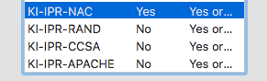

OPTION: NON-ASSERT COVENANT
NOTE: AutoText codes KI-IPR-NAC and KI-IPR-NAC-NOTICE

Tbd

OPTION: RAND
NOTE: AutoText codes KI-IPR-RAND and KI-IPR-RAND-NOTICE

Patent & Copyright: Reciprocal Royalty Free with Opt-Out to Reasonable And Non-discriminatory (RAND)
This document has been prepared by Participants of Kantara Initiative, Inc. Permission is hereby granted to use the document solely for the purpose of implementing the Specification. No rights are granted to prepare derivative works of this Specification. Entities seeking permission to reproduce portions of this document for other uses must contact Kantara Initiative to determine whether an appropriate license for such use is available.
Implementation or use of certain elements of this document may require licenses under third party intellectual property rights, including without limitation, patent rights. The Participants of and any other contributors to the Specification are not and shall not be held responsible in any manner for identifying or failing to identify any or all such third party intellectual property rights. This Specification is provided "AS IS," and no Participant in Kantara Initiative makes any warranty of any kind, expressed or implied, including any implied warranties of merchantability, non-infringement of third party intellectual property rights, and fitness for a particular purpose. Implementers of this Specification are advised to review Kantara Initiative’s website (http://www.kantarainitiative.org/) for information concerning any Necessary Claims Disclosure Notices that have been received by the Kantara Initiative Board of Directors.
Copyright: The content of this document is copyright of Kantara Initiative, Inc.
© 2017 Kantara Initiative, Inc.

OPTION: CREATIVE COMMONS ATTTRIBUTION-SHARE ALIKE
NOTE: AutoText codes KI-IPR-CCSA and KI-IPR-CCSA-NOTICE

This work is licensed under the Creative Commons Attribution-Share Alike 3.0 Unported License (CC BY-SA 3.0). To view a copy of the license, visit https://creativecommons.org/licenses/by-sa/3.0/

You are free to:
Share — copy and redistribute the material in any medium or format
Adapt — remix, transform, and build upon the material for any purpose, even commercially.
This license is acceptable for Free Cultural Works.
The licensor cannot revoke these freedoms as long as you follow the license terms.
Under the following terms:
Attribution — You must give appropriate credit, provide a link to the license, and indicate if changes were made. You may do so in any reasonable manner, but not in any way that suggests the licensor endorses you or your use.
ShareAlike — If you remix, transform, or build upon the material, you must distribute your contributions under the same license as the original.
No additional restrictions — You may not apply legal terms or technological measures that legally restrict others from doing anything the license permits.
Notices:
You do not have to comply with the license for elements of the material in the public domain or where your use is permitted by an applicable exception or limitation.
No warranties are given. The license may not give you all of the permissions necessary for your intended use. For example, other rights such as publicity, privacy, or moral rights may limit how you use the material.
For any reuse or distribution, you must make clear to others the license terms of this work. The best way to do this is with a link to this document.
Copyright © 2017 Kantara Initiative, Inc.

OPTION: APACHE CLA
NOTE: AutoText codes KI-IPR-APACHE and KI-IPR-APACHE-NOTICE

Licensed under the Apache License, Version 2.0 (the "License"); you may not use this file except in compliance with the License. You may obtain a copy of the License at: https://kantarainitiative.org/confluence/x/HIBQAQ
Unless required by applicable law or agreed to in writing, software distributed under the License is distributed on an "AS IS" BASIS, WITHOUT WARRANTIES OR CONDITIONS OF ANY KIND, either express or implied. See the License for the specific language governing permissions and limitations under the License.

Citation format
Kantara publications should include a ‘Suggested Citation’ on the cover page. The Suggested Citation gives a complete and correct citation that others can use when referencing Kantara publications.
There are two recommended formats:

xml2rfc-style example
Maler, E., “Federated Authorization for User-Managed Access (UMA) 2.0”, May 2017, <https://docs.kantarainitiative.org/uma/wg/oauth-uma-federated-authz-2.0-05.html>.

Kantara-style examples
A Report:
The Design Principles of Relationship Management Version 1.0. Kantara Initiative Identity Relationship Management Work Group. 2015-02-25. Kantara Initiative Report. https://kantarainitiative.org/file-downloads/kantara-irm-design-principles-of-relationship-final-report-v1

A Recommendation:
Identity Assurance Framework: Service Assessment Criteria 5.0. Kantara Initiative Identity Assurance Work Group. 2016-09-08. Kantara Initiative Recommendation. https://kantarainitiative.org/file-downloads/identity-assurance-framework-service-assessment-criteria/

Approval Stages
There are several approval stages for Kantara publications produced by Work Groups. The names of each document stage are:
Work Group Recommendations | Work Group Reports
Group-Editors’ Draft Document | Group-Editors’ Draft Document
Group-Approved Draft Recommendation | Group-Approved Draft Report
Public Review Draft Recommendation
Group-Approved Recommendation
Kantara Initiative Candidate Recommendation
Kantara Initiative Recommendation | Kantara Initiative Report
Note that a Recommendation may be a Technical Specification.

There are several approval stages for Kantara publications produced by Discussion Groups. The names of each document stage are:
Discussion Group Reports
Group-Editors’ Draft Document
Group-Approved Draft Report
Kantara Initiative Report

Workflow Diagrams
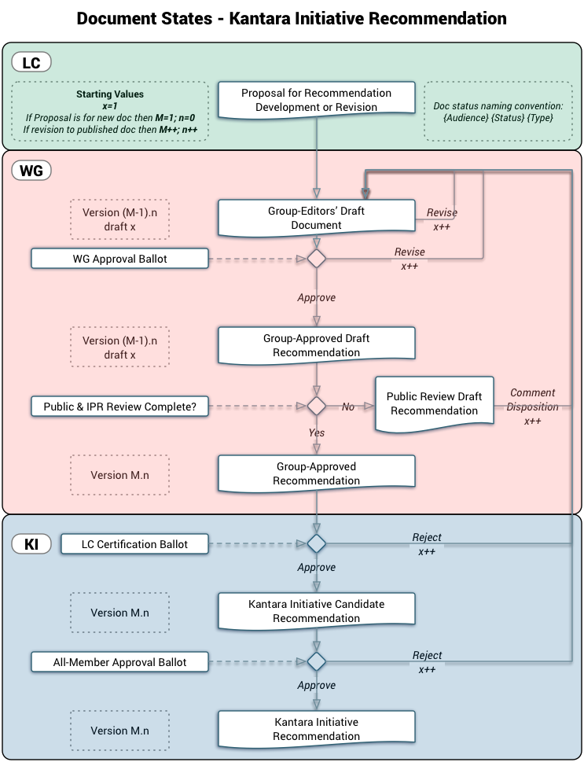
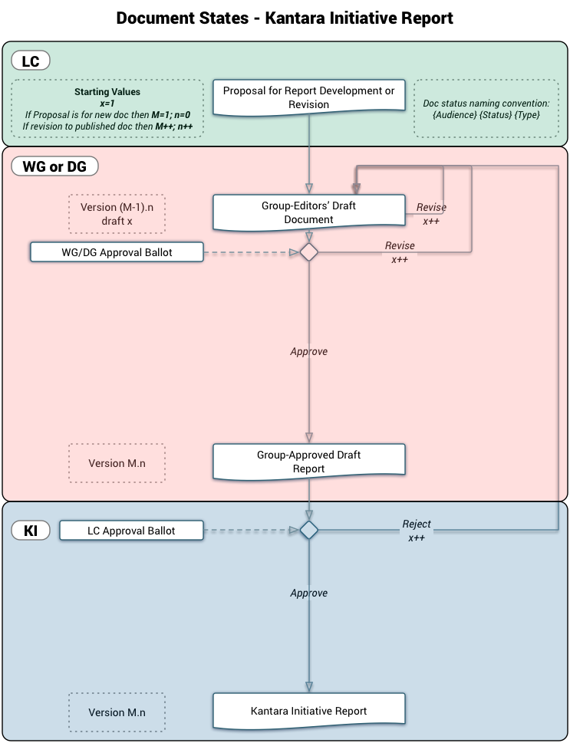

Document Status
For each of the document approval stages, specific status text must appear on the cover page.
In the following tables, the boilerplate template is:
“This document is a {Approval Stage} {Document Type} produced by the {Group HREF} {Approval Text}See the Kantara Initiative Operating Procedures {KI-OP HREF} for more information.”
{Approval Stage} indicates the highest level of document approval attained
{Document Type} indicates the type of Kantara Publication
{Group HREF} is an HTML HREF for the Group, using the Group’s full name.
{Approval Text} indicates the descriptive text for each {Approval Stage}
{KI-OP HREF} is an HTML HREF for the Kantara Operating Procedures

Custom Word Document Properties
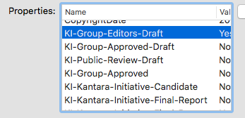

Work Group Recommendations
Status Text | Code | Approval Stage | Document Type | Approval Text AUTOTEXT
This document is a Group Editors’ Draft Document produced by the { Group HREF }. See the Kantara Initiative Operating Procedures {KI-OP HREF} for more information. | KI-S-ED | Group-Editors’ Draft | Document | .
This document is a Draft Recommendation produced by the { Group HREF }, and has been approved by the Group. See the Kantara Initiative Operating Procedures {KI-OP HREF} for more information. | KI-S-AD | Group-Approved Draft | Recommendation | , and has been approved by the Group.
This document is a Draft Recommendation produced by the { Group HREF }, and has been approved by the Group for Public Comment and Intellectual Property Rights Review. See the Kantara Initiative Operating Procedures {KI-OP HREF} for more information. | KI-S-PD | Public Review Draft | Recommendation | , and has been approved by the Group for Public Comment and Intellectual Property Rights Review.
This document is a Recommendation produced by the { Group HREF }, and has been approved by the Group. The Public Comment and Intellectual Property Rights Review has been completed. See the Kantara Initiative Operating Procedures {KI-OP HREF} for more information. | KI-S-AR | Group-Approved | Recommendation | , and has been approved by the Group. The Public Comment and Intellectual Property Rights Review has been completed.
This document is a Kantara Initiative Candidate Recommendation produced by the { Group HREF }, and has been approved by the Group. The Public Comment and Intellectual Property Rights Review has been completed. See the Kantara Initiative Operating Procedures {KI-OP HREF} for more information. | KI-S-CR | Kantara Initiative Candidate | Recommendation | , and has been approved by the Group. The Public Comment and Intellectual Property Rights Review has been completed.
This document is a Kantara Initiative Recommendation produced by the { Group HREF }. It has been approved by the Membership of the Kantara Initiative. See the Kantara Initiative Operating Procedures {KI-OP HREF} for more information. | KI-S-FR | Kantara Initiative | Recommendation | . It has been approved by the Membership of the Kantara Initiative.

Work Group Technical Specification Recommendations
Status Text | Code | Approval Stage | Document Type | Approval Text
This document is a Group Editors’ draft produced by the { Group HREF }. See the Kantara Initiative Operating Procedures {KI-OP HREF} for more information. | KI-S-ED | Group-Editors’ Draft | Document | .
This document is a Draft Technical Specification Recommendation produced by the { Group HREF }, and has been approved by the Group. See the Kantara Initiative Operating Procedures {KI-OP HREF} for more information. | KI-S-AD | Group-Approved Draft | Technical Specification Recommendation | , and has been approved by the Group.
This document is a Draft Technical Specification Recommendation produced by the { Group HREF }, and has been approved by the Group for Public Comment and Intellectual Property Rights Review. See the Kantara Initiative Operating Procedures {KI-OP HREF} for more information. | KI-S-PD | Public Review Draft | Technical Specification Recommendation | , and has been approved by the Group for Public Comment and Intellectual Property Rights Review.
This document is a Technical Specification Recommendation produced by the { Group HREF }, and has been approved by the Group. The Public Comment and Intellectual Property Rights Review has been completed. See the Kantara Initiative Operating Procedures {KI-OP HREF} for more information. | KI-S-AR | Group-Approved | Technical Specification Recommendation | , and has been approved by the Group. The Public Comment and Intellectual Property Rights Review has been completed.
This document is a Kantara Initiative Candidate Technical Specification Recommendation produced by the { Group HREF }, and has been approved by the Group. The Public Comment and Intellectual Property Rights Review has been completed. See the Kantara Initiative Operating Procedures {KI-OP HREF} for more information. | KI-S-CR | Kantara Initiative Candidate | Technical Specification Recommendation | , and has been approved by the Group. The Public Comment and Intellectual Property Rights Review has been completed.
This document is a Kantara Initiative Recommendation produced by the { Group HREF }. It has been approved by the Membership of the Kantara Initiative. See the Kantara Initiative Operating Procedures {KI-OP HREF} for more information. | KI-S-FR | Kantara Initiative | Technical Specification Recommendation | . It has been approved by the Membership of the Kantara Initiative.

Work Group Reports
Status Text | Code | Approval Stage | Document Type | Approval Text
This document is a Group Editors’ draft produced by the { Group HREF }. See the Kantara Initiative Operating Procedures {KI-OP HREF} for more information. | KI-S-ED | Group-Editors’ Draft | Document | .
This document is a Draft Report produced by the { Group HREF }, and has been approved by the Group. See the Kantara Initiative Operating Procedures {KI-OP HREF} for more information. | KI-S-AD | Group-Approved Draft | Report | , and has been approved by the Group.
This document is a Kantara Initiative Report produced by the { Group HREF }. It has been approved by the Leadership Council of the Kantara Initiative. See the Kantara Initiative Operating Procedures {KI-OP HREF} for more information. | KI-S-LCR | Kantara Initiative | Report | . It has been approved by the Leadership Council of the Kantara Initiative.

Discussion Group Reports
Status Text | Code | Approval Stage
This document is a Group Editors’ draft produced by the { Group HREF }. See the Kantara Initiative Operating Procedures {KI-OP HREF} for more information. | KI-S-ED | Group-Editors’ Draft | Document | .
This document is a Draft Report produced by the { Group HREF }, and has been approved by the Group. See the Kantara Initiative Operating Procedures {KI-OP HREF} for more information. | KI-S-AD | Group-Approved Draft | Report | , and has been approved by the Group.
This document is a Kantara Initiative Report produced by the { Group HREF }. It has been approved by the Leadership Council of the Kantara Initiative. See the Kantara Initiative Operating Procedures {KI-OP HREF} for more information. | KI-S-LCR | Kantara Initiative | Report | . It has been approved by the Leadership Council of the Kantara Initiative.

Word Template Document Status Automation Notes
The document status in the Word document template is automated using a combination of document property variables and the MS Word AutoText feature.
The Cover page displays the core metadata for the publication: name, version, who created it, IPR Option, copyright, abstract and suggested citation. The information on the Cover page sufficiently describes the document for version control, approval ballots, publication and referencing.
Most of these Elements are automatically generated from document metadata in the document Advanced Properties and Custom Properties.
The Version, Document Date and Contributors Elements are edited directly on the Cover Page. Special Character Styles have been applied to these elements to allow their text to appear in different places in the document.

The ‘Code’ in the tables above is the index to the AutoText entries.

