Instruction Sheet:
Kantara Logo in Email Signature

Gmail

You can put up to 10,000 characters in your signature.
- Open Gmail (Go to gmail.com)
- In the top right, click Settings Settings.

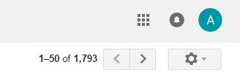

- In the "Signature" section, add your signature text in the box. If you want, you can format your message by adding an image or changing the text style.
Click this to upload a picture or logo into your signature
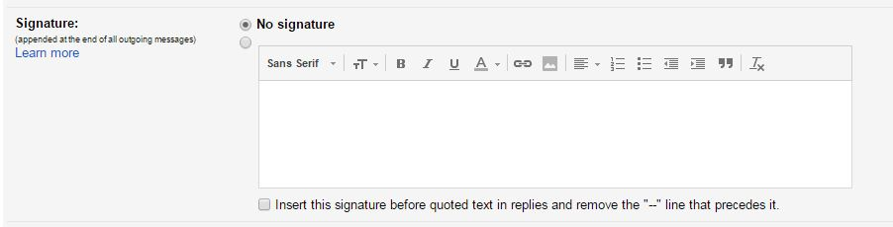

- At the bottom of the page, click Save Changes.
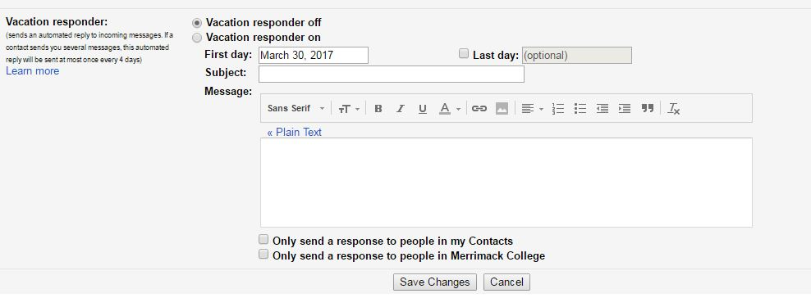

Microsoft Outlook
- Click File > Options
- Click “Mail” on left hand side
- Click Signatures

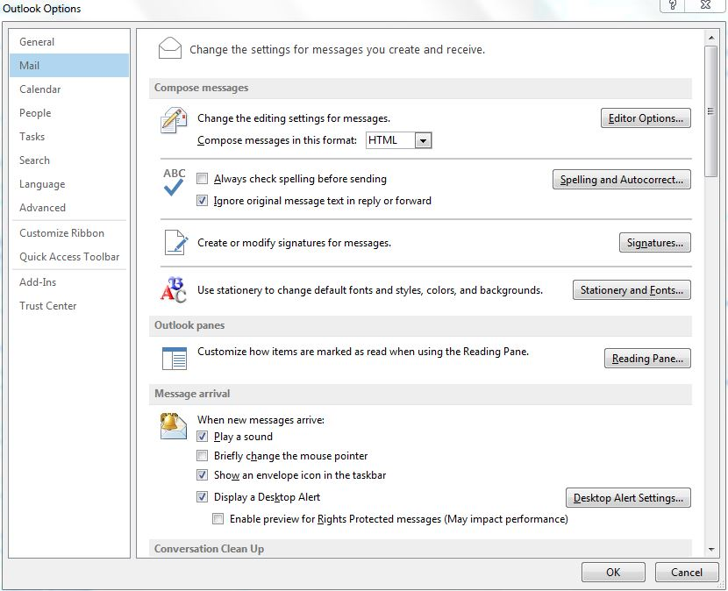

- Click New > Enter your name
- Add information into text body
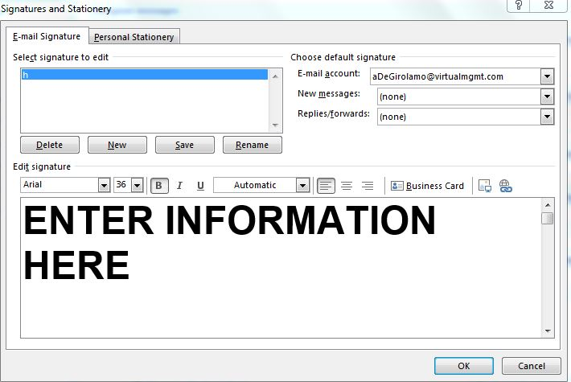

Click here to upload image or logo

- Hit OK

MAC OS Mail
- Select Mail > Preferences from the menu
  - You can also press Command, (comma)

- Go to Signature tab
- Choose Mail > Preferences, then click Signatures.
- In the left column, select the email account you want to use the signature for, then click .
  - You can drag signatures from one account to another, or to and from All Signatures. If you create a signature in All Signatures, you must drag it to an account to use it.
- In the middle column, type a name for the signature.
  - The name appears in the Signature pop-up menu in the message header when you write a message.
- In the right column (the preview), create your signature.
  - You can use the Edit or Format menus in Mail to change the font or layout, turn text into links, or check spelling. To add an image, drag the file into the preview.
- If you want your signature to appear after the original text of messages you reply to or forward, deselect the “Place signature above quoted text” checkbox.

