Consent Receipt Specification
Version: 1.1.0 DRAFT 6
Date: 2017-11-17
Editor: Mark Lizar, David Turner
Contributors: Iain Henderson, Mary Hodder, Harri Honko, Oliver Maerz,
Eve Maler, John Wunderlich, Richard Beaumont,
Samuli Tuoriniemi, Rupert Graves, Chris Cooper, Sal D'Agostino, Jim Pasquale, Robert Lapes, Tom Jones
Status: Kantara Initiative DRAFT Recommendation Candidate

Abstract:
A Consent Receipt is an open standard. It is a human-readable record of consent that can be stored or transmitted in standard JSON. It can be used by a PII Controller as a record of their authority to collect, use, or disclose a PII Principal’s personally identifiable information (PII). The Consent Receipt will be proffered to the PII Principal whose consent has been recorded. This specification defines the requirements for the creation of a consent record and the provision of a human-readable receipt. The standard includes requirements for links to existing privacy notices & policies as well as a description of what information has been or will be collected, the purposes for that collection as well as relevant information about how that information will be used or disclosed.
This specification is based on current privacy and data protection principles as set out in various data protection laws, regulations and international standards.
IPR:
Reciprocal Royalty Free with Opt-Out to Reasonable and Non-discriminatory (RAND) HTML version | Copyright ©2017 http://kantarainitiative.org/confluence/x/DYBQAQ
Notice:
Copyright (c) 2017 Kantara and the persons identified as the document authors. All rights reserved.
This document is subject to the Kantara IPR Policy - Option Patent & Copyright: Reciprocal Royalty Free with Opt-Out to Reasonable and Non-discriminatory (RAND) HTML version
Need text for “About Kantara”
Table of Contents
Abstract: 1
1 Introduction 3
2 Notations and Abbreviations 4
3 Terms and definitions 5
4 Elements of a Consent Receipt 10
4.1 Introduction 10
4.2 Conformance 10
4.3 Consent Receipt Transaction Fields 10
4.4 Consent Transaction Parties Fields 11
4.5 Data, Collection, and Use Fields 13
4.6 Presentation and Delivery 15
4.7 JSON Schema 16
5 Considerations 20
5.1 A Consent Receipt is PII 20
5.2 Sensitive PII: Liability & Compliance 20
5.3 Security and Integrity 21
6 Acknowledgements 22
7 References 23
Appendix A: Example Consent Receipts 25
Revision history 30

Introduction
Current regulations and best practices for privacy protection include requirements for notice and consent. There is no standard or specification for an interoperable consent record. As a result, individuals cannot easily track their consents or know who to hold accountable in the event of a violation of their consent.
Individuals are regularly asked for consent by organizations who want to collect information about them, usually in conjunction with the use of a service or application. Consent is provided by an individual when they agree to allow an organization to collect, use, or disclose their data, and data about them, according to a set of terms and conditions defined by the collecting organization.
A record of a consent enhances the ability to maintain and manage permissions for personal data by both the individual and the organization. Much like a retailer giving a customer a cash register receipt as a record of a purchase transaction, an organization should similarly create a record of a consent interaction and give it to the individual, defined here as a Consent Receipt (CR), to memorialize this interaction in a way that is useful to people. The creation and implementation of this standardized format will promote consistent consent practices, support consent management interoperability between systems, and enable proof of consent.
The CR elements described in this specification represent privacy-related requirements common to many jurisdictions. A JavaScript Object Notation (JSON) schema for a CR is included to enable interoperable data exchange and processing. The specification includes extension points so that implementors can incorporate information required for their particular regulatory and policy requirements.
The OECD Guidelines Council of Europe Convention and European Union Data Protection Directive [EU-DATA] relied on FIPs [FIPS] as core principles. All three organizations revised and extended the original U.S. statement of FIPs. Due to the international and cross-domain use of a consent receipt, this document refers to the 1980 OECD Guidelines on the Protection of Privacy and Transborder Flows of Personal Data [OECD] focusing on consent using the ISO 29100 lexicon.

Notations and Abbreviations
The keywords "MUST", "MUST NOT", "REQUIRED", "SHALL", "SHALL NOT", "SHOULD", "SHOULD NOT", "RECOMMENDED", “NOT RECOMMENDED”, "MAY", and "OPTIONAL" in this document are to be interpreted as described in [RFC 2119].
All JSON [RFC 7159] properties and values are case sensitive. JSON data structures defined by this specification MAY contain extension properties that are not defined in this specification. Any entity receiving or retrieving a JSON data structure SHOULD ignore extension properties it is unable to understand. Extension names that are unprotected from collisions are outside the scope of this specification. https://docs.kantarainitiative.org/uma/rec-uma-core.html# - RFC7159

The following abbreviations are used:
CR Consent Receipt
FIPS FOIA/PA Information Processing System
GDPR General Data Protection Regulation
JSON JavaScript Object Notation
JWT JSON Web Token
PI Personal Information
PII Personally Identifiable Information

Terms and definitions
This specification uses terminology and definitions from ISO/IEC 29100:2011 "Information Technology -- Security techniques -- Privacy Framework" [ISO 29100:2011] and other published, FIPS-based best practices, to maintain consistency with the terms commonly used in regulations. If a jurisdiction’s terms are not compatible with this specification, these internationally-defined terms can be mapped to localized terms. For example, PII Principal in this document maps to the term Data Subject in European legislation. For ease of mapping and use, this document will define those terms for clarity and specificity for this specification.
Although this specification uses the ISO 29100 lexicon, its use of this language is not prescriptive, and the terms should be replaced according to the jurisdiction that regulates its provision. The specification is based on privacy and data protection principles as set out in various data protection laws, regulations and international standards

Collection
Receiving, creating, or obtaining data from or about a PII Principal.

Disclosure
The transfer, copy, or communication, by a PII Controller or a PII Processor acting on behalf of the PII Controller, of PII and accountability for that PII when transferred to another entity, which will become the PII Controller of that PII.
NOTE: When a PII Controller transfers or copies information to another entity it retains accountability for that PII. An example would be an entity using a cloud storage service for backups. We note this here because, for a PII Principal, both this ‘use’ and actual ‘disclosure’ may be termed ‘sharing’ information. However, there are significant differences from a transparency and regulatory point of view.

Consent
A Personally identifiable information (PII) Principal’s freely given, specific and informed agreement to the processing of their PII.
[SOURCE: ISO 29100]

Consent Receipt
A record of a consent interaction (or consent record summary linked to the record of consent) provided by a PII Principal to a PII Controller to collect, use and disclose the PII Principal’s PII in accordance with an agreed set of terms.

Consent Timestamp
The time and date when consent was obtained from the PII Principal.

Consent Type
The type of the consent used by the PII Controller as their authority to collect, use or disclose PII.

Explicit (Expressed) Consent
The PII Principal has an opportunity to provide a specific indication that they consent to the collection of their PII for purposes that have been specified in a prior notice or are provided at the time of collection.
[Europe 5.4.4]

Human-readable
(Of text, data, etc.) in a form that can be naturally or easily read by a person (frequently in contrast to computer-readable, machine-readable).
[SOURCE: OXFORD]

Implicit (Implied) Consent
The PII Controller has a reasonable expectation to believe that consent already exists for the collection of the PII.

Opt-in
A process or type of policy whereby the personally identifiable information (PII) principal is required to take an action to express explicit, prior consent for their PII to be processed for a particular purpose.
[SOURCE: ISO 29100]
Note: If the PII Principal does nothing, consent will not have been obtained.

Opt-out
A process or type of policy whereby the PII principal is required to take a separate action in order to withhold or withdraw consent, or oppose a specific type of processing.
[SOURCE: ISO 29100]
Note: If the PII Principal does nothing, consent will have been deemed to have been obtained.

Privacy Statement
A notice published or provided by the PII Controller to inform the PII Principal of what will be done with their information.
Note: The contents of this notice may be required by regulation and may include information that is beyond the scope of this specification.

Personally Identifiable Information (PII)
Any information that (a) can be used to identify the PII Principal to whom such information relates, or (b) is or might be directly or indirectly linked to a PII Principal.
NOTE: To determine whether or not an individual should be considered identifiable, several factors need to be taken into account.
[SOURCE: ISO 29100]

PII Controller
A privacy stakeholder (or privacy stakeholders) that determines the purposes and means for processing personally identifiable information (PII) other than natural persons who use data for personal purposes.
NOTE: A PII controller sometimes instructs others (e.g., PII processors) to process PII on its behalf while the responsibility for the processing remains with the PII controller.
[SOURCE: ISO 29100]
Note: may also be called data controller.

PII Principal
The natural person to whom the personally identifiable information (PII) relates.
NOTE: Depending on the jurisdiction and the particular data protection and privacy legislation, the synonym “data subject” can also be used instead of the term “PII principal.”
[SOURCE: ISO 29100]

PII Processor
A privacy stakeholder that processes personally identifiable information (PII) on behalf of and in accordance with the instructions of a PII controller.
[SOURCE: ISO 29100]

Processing of PII
An operation or set of operations performed upon personally identifiable information (PII).
NOTE: Examples of processing operations of PII include, but are not limited to, the collection, storage, alteration, retrieval, consultation, disclosure, anonymization, pseudonymization, dissemination or otherwise making available, deletion or destruction of PII.
[SOURCE: ISO 29100]

Privacy Stakeholder
A natural or legal person, public authority, agency or any other body that can affect, be affected by, or perceive themselves to be affected by a decision or activity related to personally identifiable information (PII) processing
[SOURCE: ISO 29100]

Purpose
1. The business, operational or regulatory requirement for the collection, use and/or disclosure of a PII Principal's data.
2. The reason personal information is collected by the entity.
[SOURCE: GAPP]

Third Party
A privacy stakeholder other than the personally identifiable information (PII) principal, the PII controller and the PII processor, and the natural persons who are authorized to process the data under the direct authority of the PII controller or the PII processor.
[SOURCE: ISO 29100]

Sensitive PII
Sensitive Categories of personal information as defined in regulation (or potentially by the PII Principal), either whose nature is sensitive, such as those that relate to the PII principal’s most intimate sphere, or that might have a significant impact on the PII principal. These categories are specified as sensitive in FIP’s based legislation and refer specifically to racial origin, political opinions or religious or other beliefs, personal data on health, sex life or criminal convictions and require opt-in informed consent.
NOTE: In some jurisdictions or in specific contexts, sensitive PII is defined in reference to the nature of the PII and can consist of PII revealing the racial origin, political opinions or religious or other beliefs, personal data on health, sex life or criminal convictions, as well as other PII that might be defined as sensitive.
[SOURCE: ISO 29100]
Sensitive Personal Information (SPI) is defined as information that if lost, compromised, or disclosed could result in substantial harm, embarrassment, inconvenience, or unfairness to an individual.
[SOURCE: DHS HSSPII]
NOTE: For this specification, 'Sensitive data' may be considered synonymous with Sensitive PII. Sensitive Data is defined in Section 2 of the Data Protection Act of the UK (http://www.legislation.gov.uk/ukpga/1998/29/section/2) as personal data consisting of information relating to the data subject concerning racial or ethnic origin; political opinions; religious beliefs or other beliefs of a similar nature; trade union membership; physical or mental health or other data or as defined by implementers of the specification. In the [GDPR], this is referred to as special categories of data.

Use
Any processing of PII done by a PII Controller or by a PII processor on behalf of a PII Controller.
NOTE: “collection, use, and disclosure” is a useful articulation of the steps in PII processing.

Elements of a Consent Receipt

Introduction
The following sub-sections define all the fields for a consent receipt including the corresponding JSON field names and types. This specification uses “named object” data types to describe the principal concepts within the consent receipt and allows for extension by implementers. See the JSON schema for object implementation.

Conformance
A Consent Receipt MUST include the fields defined as REQUIRED below. When using JSON, the Consent Receipt MUST also be valid per the Consent Receipt schema in Section 4.7.

Consent Receipt Transaction Fields
This section defines the administrative fields for the consent transaction and the metadata for the overall Consent Receipt.
    - Version
REQUIRED: The version of this specification to which a receipt conforms. The value MUST be “KI-CR-v1.1.0” for this version of the specification.
JSON: version, type: string
    - Jurisdiction
REQUIRED: The jurisdiction(s) applicable to this transaction. This field MUST contain a non-empty string describing the jurisdiction(s).
JSON: jurisdiction, type: string
    - Consent Timestamp
REQUIRED: Date and time of the consent transaction. The JSON value MUST be expressed as the number of seconds since 1970-01-01 00:00:00 GMT. ISO8601 https://en.wikipedia.org/wiki/ISO_8601 MUST be used for formatting.
JSON: consentTimestamp, type: integer
    - Collection Method
REQUIRED: A description of the method by which consent was obtained. Collection Method is a key field for context and determining what fields MUST be used for the Consent Receipt. This field MUST contain a non-empty string.
JSON: collectionMethod, type: string
    - Consent Receipt ID
REQUIRED: A unique number for each Consent Receipt. SHOULD use UUID-4 [RFC 4122]. This field MUST contain a non-empty string.
JSON: consentReceiptID, type: string
    - Public Key
OPTIONAL: The PII Controller’s public key.
JSON: publicKey, type: string
    - Language
OPTIONAL: Language in which the consent was obtained. MUST use ISO 639-1:2002, Codes for the representation of names of languages — Part 1: Alpha-2 code if this field is used.
JSON: language, type: string

Consent Transaction Parties Fields
This section defines information about the parties involved in the consent process.
    - PII Principal ID
REQUIRED: PII Principal-provided identifier. E.g., email address, claim, defined/namespace. Consent is not possible without an identifier. This field MUST contain a non-empty string.
JSON: piiPrincipalId, type: string
    - piiControllers
REQUIRED: An array that contains one or more items where each item represents one PII Controller. It is only required for the JSON encoding of a consent receipt.
JSON: piiControllers, type: array
    - PII Controller
REQUIRED: Name of the first PII Controller who collects the data. This entity is accountable for compliance with the management of PII. The PII Controller determines the purpose(s) and type(s) of PII processing. There may be more than one PII Controller for the same set(s) of operations performed on the PII. In this case, the different PII Controllers SHOULD be listed, and it MUST be listed for Sensitive PII with legally required explicit notice to the PII Principal. This field MUST contain a non-empty string.
JSON: piiController, type: string
    - On Behalf
OPTIONAL: A PII Processor acting on behalf of a PII Controller or PII Processor. For example, a third-party analytics service would be a PII Processor on behalf of the PII Controller, or a site operator acting on behalf of the PII Controller.
JSON: onBehalf, type: boolean
    - PII Controller Contact
REQUIRED: Contact name of the PII Controller. This field MUST contain a non-empty string.
JSON: contact, type: string
    - PII Controller Address
REQUIRED: The physical address of PII controller. Postal address for contacting the PII Controller. https://schema.org/PostalAddress. This field MUST contain a non-empty string.
JSON: address, type: object
    - PII Controller Email
REQUIRED: Contact email address of the PII Controller. The direct email to contact the PII Controller regarding the consent or privacy contract. This field MUST contain a non-empty string.
JSON: email, type: string
    - PII Controller Phone
REQUIRED: Contact phone number of the PII Controller. The business phone number to contact the PII Controller regarding the consent. MUST conform to RFC 3966 https://tools.ietf.org/html/rfc3966. This field MUST contain a non-empty string.
JSON: phone, type: string
    - PII Controller URL
OPTIONAL: A URL for contacting the PII Controller.
JSON: piiControllerURL, type: string
    - Privacy Policy
REQUIRED: A link to the PII Controller’s privacy statement/policy and applicable terms of use in effect when the consent was obtained, and the receipt was issued. If a privacy policy changes, the link SHOULD continue to point to the old policy until there is evidence of an updated consent from the PII Principal. This field MUST contain a non-empty string.
JSON: policyURL, type: string

Data, Collection, and Use Fields
This section defines the fields for services, personal information categories, attributes, PII confidentiality level, and PII Sensitivity.
    - services
REQUIRED: An array that contains one or more items where each item represents one Service. It is only required for the JSON encoding of a consent receipt.
JSON: service, type: array
    - Service
REQUIRED: The service or group of services being provided for which PII is collected. The name of the service for which consent for the collection, use, and disclosure of PII is being provided. This field MUST contain a non-empty string.
JSON: service, type: string
    - purposes
REQUIRED: An array that contains one or more items where each item represents one Purpose. It is only required for the JSON encoding of a consent receipt.
JSON: purposes, type: array
    - Purpose
OPTIONAL: A short, clear explanation of why the PII item is required.
JSON: purpose, type: string
    - Purpose Category
REQUIRED: The reason the PII Controller is collecting the PII. Example Purpose Categories currently in use are available on the Kantara Consent & Information Sharing Work Group (CISWG) Wiki page (https://kantarainitiative.org/confluence/x/74K-BQ). This field MUST contain a non-empty string.
JSON: purposeCategory, type: string
    - Consent Type
REQUIRED: The type of the consent used by the PII Controller as their authority to collect, use or disclose PII. The field MUST contain a non-empty string and the default value is “EXPLICIT”. If consent was not explicit, a description of the consent method MUST be provided. This field MUST contain a non-empty string.
JSON: consentType, type: string
    - PII Categories
REQUIRED: A list of defined PII categories. PII Category should reflect the category that will be shared as understood by the PII Principal. More information can be found on the Kantara Consent & Information Sharing Work Group (CISWG) Wiki page. (https://kantarainitiative.org/confluence/x/74K-BQ). This field MUST contain a non-empty string.
JSON: piiCategory, type: array
    - Primary Purpose
REQUIRED: Indicates if a purpose is part of the core service of the PII Controller. Possible values are TRUE or FALSE.
JSON: primaryPurpose, type: boolean
    - Termination
REQUIRED: Conditions for the termination of consent. Link to policy defining how consent or purpose is terminated. This field MUST contain a non-empty string.
JSON: termination, type: string
    - Third Party Disclosure
REQUIRED: Indicates if the PII Controller is disclosing PII to a third party. Possible values are TRUE or FALSE.
JSON: thirdPartyDisclosure, type: boolean
    - Third Party Name
REQUIRED: The name or names of the third party to which the PII Processor may disclose the PII. MUST be supplied if Third Party Disclosure is TRUE and MUST contain a non-empty string.
JSON: thirdPartyName, type: string
    - Sensitive PII
REQUIRED: Indicates whether the consent interaction contains PII that is designated sensitive or not sensitive. Possible values are TRUE or FALSE. A value of TRUE indicates that data covered by the Consent Receipt is sensitive, or could be interpreted as sensitive, which indicates that there is policy information out-of-band of the Consent Receipt.
JSON: sensitive, type: boolean
    - Sensitive PII Category
REQUIRED: A listing of categories where PII data collected is sensitive. The field MUST contain a non-empty string if Sensitive PII is TRUE.
JSON: spiCat, type: array
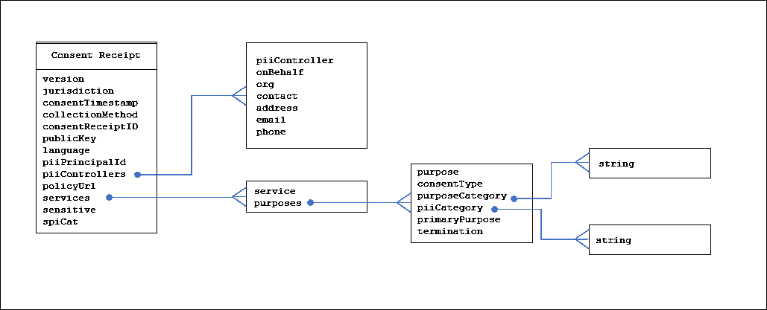
Figure 1: Consent Receipt data structure

Presentation and Delivery
Although a CR can be provisioned in any manner that is feasible or expected based on the context, a CR MUST be provided to the PII Principal in a human-readable format either on screen or delivered to the PII Principal, or both. A JSON encoded CR MAY also be delivered to the PII Principal.
We note that in some use cases, the PII Controller may primarily depend upon a proprietary consent management system that may display a receipt on demand. So long as the presentation UI contains the information set out in this standard, it will be deemed to be a human-readable consent receipt.
NOTE: Issues such as language translation, localization, human-readable layout and formatting, and delivery mechanisms are out-of-scope for this document.

JSON Schema
{
// Kantara Consent Receipt Specification v 1.1.0 DRAFT 6
//2017-11-17

"$schema": "http://json-schema.org/draft-04/schema#",
"type": "object",
"properties": {
"version": {
"type": "string"
},
"jurisdiction": {
"type": "string"
},
"consentTimestamp": {
"type": "integer",
"minimum" : 0
},
"collectionMethod": {
"type": "string"
},
"consentReceiptID": {
"type": "string"
},
"publicKey": {
"type": "string"
},
"language": {
"type": "string"
},
"piiPrincipalId": {
"type": "string"
},
"piiControllers": {
"type": "array",
"items": {
"type": "object",
"properties": {
"piiController": {
"type": "string"
},
"onBehalf": {
"type": "boolean"
},
"contact": {
"type": "string"
},
"address": {
"type": "object"
},
"email": {
"type": "string"
},
"phone": {
"type": "string"
},
"piiControllerUrl": {
"type": "string"
}
},
"required": [
"piiController",
"contact",
"address",
"email",
"phone"
]
}
},
"policyUrl": {
"type": "string"
},
"services": {
"type": "array",
"items": {
"type": "object",
"properties": {
"service": {
"type": "string"
},
"purposes": {
"type": "array",
"items": {
"type": "object",
"properties": {
"purpose": {
"type": "string"
},
"consentType": {
"type": "string"
},
"purposeCategory": {
"type": "array",
"items": {
"type": "string"
}
},
"piiCategory": {
"type": "array",
"items": {
"type": "string"
}
},
"primaryPurpose": {
"type": "boolean"
},
"termination": {
"type": "string"
}
},
"oneOf": [
{
"properties": {
"thirdPartyDisclosure": {
"type": "boolean",
"enum": [
false
]
}
},
"required": [
"thirdPartyDisclosure"
]
},
{
"properties": {
"thirdPartyDisclosure": {
"type": "boolean",
"enum": [
true
]
},
"thirdPartyName": {
"type": "string"
}
},
"required": [
"thirdPartyDisclosure",
"thirdPartyName"
]
}
],
"required": [
"consentType",
"purposeCategory",
"piiCategory",
"termination",
"thirdPartyDisclosure"
]
}
}
},
"required": [
"service",
"purposes"
]
}
},
"sensitive": {
"type": "boolean"
},
"spiCat": {
"type": "array",
"items": {
"type": "string"
}
}
},
"required": [
"version",
"jurisdiction",
"consentTimestamp",
"collectionMethod",
"consentReceiptID",
"piiPrincipalId",
"piiControllers",
"services",
"policyUrl",
"sensitive",
"spiCat"
]
}

Considerations
Consent is how people regulate privacy in context. As a social control, consent is the signal people provide when they share personal information that is specific to a particular context. When broken down, the nature of consent for human communication and signaling can be observed in different ways: as implicit consent, opt-out consent, and explicit consent.
With each consent policy notice and a Consent Receipt implementation, there are different user experience, legal, privacy, and security-related considerations for the collection disclosure and use of PII consent by the PII Controller.

A Consent Receipt is PII
A Consent Receipt combines personal information with the agreement for its use for the PII Controller to provide services. A Consent Receipt links multiple attributes of personal information with an identifier, which when linked to other attributes or with an identity, constitutes PII. In all jurisdictions, consent for sensitive personal information requires explicit consent, which is prescribed and regulated by privacy law.

Sensitive PII: Liability & Compliance
In this document, sensitive data collection is indicated with Sensitive PII flag and is required. If sensitive=TRUE, then the Consent Receipt has limited liability for the provider as different jurisdictions have legal requirements for what is classified as sensitive. In addition, the implementer can define what is sensitive, or confidential, in their privacy policy, even if not classified as sensitive in a particular jurisdiction.
If the implementer selects sensitive=TRUE because sensitive data is collected, but, does not provide the categories of sensitive personal information with Sensitive PII Category field, then it is assumed that what is sensitive and how it is managed will be found in the privacy policy linked to in the Consent Receipt.
The provision of a Consent Receipt with sensitive=TRUE indicates the provider of the receipt is liable for providing the correct collection, use and disclosure notice as required by law in the jurisdiction in which it was provisioned. As a result, there are three levels of liability to consider for Consent Receipts by the implementer:
- Provision of the Consent Receipt for non-sensitive PII (sensitive=FALSE)

  - Provision of a sensitive Consent Receipt with the sensitive=TRUE and sensitive PII categories are listed. Sensitive PII Categories must be listed in the Consent Receipt for the Consent Receipt to be used for a compliance claim. In this manner, the receipt can inherently demonstrate compliance with consent notice requirements for the particular consent.
  - If the Sensitive PII category is not listed in the Consent Receipt, the Consent Receipt must not be considered transparent enough itself to be a compliance claim, which impacts liability.
NOTE: In multiple jurisdictions, there are categories listed as sensitive personal information. If the use, collection or disclosure of sensitive personal information have legal requirements as defined in regulation, explicit consent is required and can have jurisdiction-specific legal notice requirements to be informed. For example, PII revealing the racial origin, political opinions or religious or other beliefs, personal data on health, sex life or criminal convictions, as well as other PII that are defined as sensitive in regulation.

Security and Integrity
    - Overview
Since Consent Receipts can contain PII, it is a requirement that transmission of Consent Receipts does not take place in the clear and that secure communications be used, e.g., HTTPS. The requirements for implementers of consent receipts and consent management include signing, encryption, key management and other operations for their creation, transmission, use, and storage if the consent receipt is to be used for proof of consent, withdrawal of consent or any other rights.
    - Guidance
- Ensure the use of securely authenticated connections using modern cryptology.
- If a receipt contains PII - a receipt without PII is not in scope here - and it is transmitted securely, the user must be able to manage the receipt interactions with:
  - Storage (local machine, server, client, application, device, etc.)
  - Other receipt repositories and consent services.
    - Security of these repositories and services - i.e., non-local, requires considerations but is currently out-of-scope of this specification.
    - When considered it should include the use case where for some reason a receipt has not been transmitted it should be available from the provider of the receipt repository for direct download. Such infrastructure is out-of-scope for this specification.
  - Transmission of receipts with PII.
- The ability to validate and revoke the receipt – and other aspects of the consent receipt lifecycle are out-of-scope for this specification at this time but will need to be taken up shortly. Additional topics for future consideration include:
  - Consent best practices.
  - Status and revocation of consent.
  - Consent management, validation, and other aspects of its lifecycle.
The transmission of a JSON Consent Receipt should use the following specifications:
JSON Web Token (JWT) [RFC 7519]
JSON Web Encryption (JWE) [RFC 7516]
JSON Web Signature (JWS) [RFC 7515]

Acknowledgements
The Consent Receipt effort has been developed in the Kantara Community, supported by people who have invested in making this specification open and free to use. It is free so that people can have a common way to see what consents have been provided and what data is being shared or disclosed. If you wish to provide feedback, you may join the Kantara Working Group, and then email us on our list at wg-infosharing@kantarainitiative.org or send feedback to info@consentreceipt.org.
In addition to Kantara, we wish to thank the following contributors to the Consent Receipt effort:
Customer Commons
Colin Wallis
Sal D’Agostino
Andrew Hughes
Justin Richer
Sarah Squire
Eve Maler
The Consent Receipt standardization effort has been developed with the support of many communities, as noted in our acknowledgments section, and leverages best of breed standards, legal regulation and technical practices in its design and development, as noted in the references section.

References
[DHS HSSPII] DHS Handbook for Safeguarding Sensitive PII. (Ed. 2012). https://www.dhs.gov/sites/default/files/publications/privacy/Guidance/handbookforsafeguardingsensitivePII_march_2012_webversion.pdf
[EU-DATA] Directive 95/46/EC of the European Parliament and of the Council of 24 October 1995 on the protection of individuals with regard to the processing of personal data and on the free movement of such data. http://eur-lex.europa.eu/legal-content/EN/TXT/?uri=CELEX:31995L0046
[Europe 5.4.4] Kosta, E., Consent in European Data Protection Law. Section 5.4: “Consent in the Context of Sensitive Data.” (Ed: 2013) p. 98-100. https://goo.gl/JGPX2Y
[FIPS] Privacy Impact Assessment for the FOIA/PA Information Processing System. https://www.dhs.gov/xlibrary/assets/privacy/privacy-pia-fips.pdf
[GAPP] Generally Accepted Privacy Principles - developed through joint consultation with the Canadian Institute of Chartered Accountants (CICA) and the American Institute of Certified Public Accountants (AICPA) through the AICPA/CICA Privacy Task Force. https://www.cippguide.org/2010/07/01/generally-accepted-privacy-principles-gapp/
[GDPR] General Data Protection Regulation, http://www.eugdpr.org/article-summaries.html
[ISO 18001-1:2005] Information technology — Personal identification — ISO-compliant driving license — Part 1: Physical characteristics and basic data set. https://www.iso.org/obp/ui/#iso:std:iso-iec:18013:-1:ed-1:v1:en
[ISO 29100:2011] Information technology -- Security techniques -- Privacy framework. http://www.iso.org/iso/iso_catalogue/catalogue_tc/catalogue_detail.htm?csnumber=45123
[PIPEDA] Personal Information Protection and Electronic Documents Act, http://laws-lois.justice.gc.ca/eng/acts/P-8.6/index.html
[RFC 2119] Bradner, S., “Key words for use in RFCs to Indicate Requirement Levels”, BCP 14, RFC 2119, DOI 10.17487/RFC2119, March 1997 http://www.rfc-editor.org/info/rfc2119
[RFC 4122] P. Leach, M. Mealling, R. Salz, “A Universally Unique IDentifier (UUID) URN Namespace”, RFC 4122, 10.17487/RFC4122, July 2005, https://tools.ietf.org/html/rfc4122
[RFC 7159] Bray, T., Ed., “The JavaScript Object Notation (JSON) Data Interchange Format”, RFC 7159, DOI 10.17487/RFC7159, March 2014, http://www.rfc-editor.org/info/rfc7159
[RFC 7515] M. Jones, J. Bradley, N. Sakimura, “JSON Web Signature (JWS)”, RFC 7515, May 2015, https://tools.ietf.org/html/rfc7515
[RFC 7516] M. Jones, J. Hildebrand, “JSON Web Encryption (JWE)”, RFC 7516, May 2015, https://tools.ietf.org/html/rfc7516
[RFC 7519] M. Jones, J. Bradley, N. Sakimura, “JSON Web Token (JWT)”, RFC 7519, DOI 10.17487/RFC7519, May 2015, https://tools.ietf.org/html/rfc7519
[OECD] OECD Guidelines on the Protection of Privacy and Transborder Flows of Personal Data. http://www.oecd.org/sti/ieconomy/oecdguidelinesontheprotectionofprivacyandtransborderflowsofpersonaldata.htm
[OXFORD] Oxford University Press - Definition of human-readable in English, https://en.oxforddictionaries.com/definition/us/human-readable
- Example Consent Receipts
- Human-readable Consent Receipt – Simple
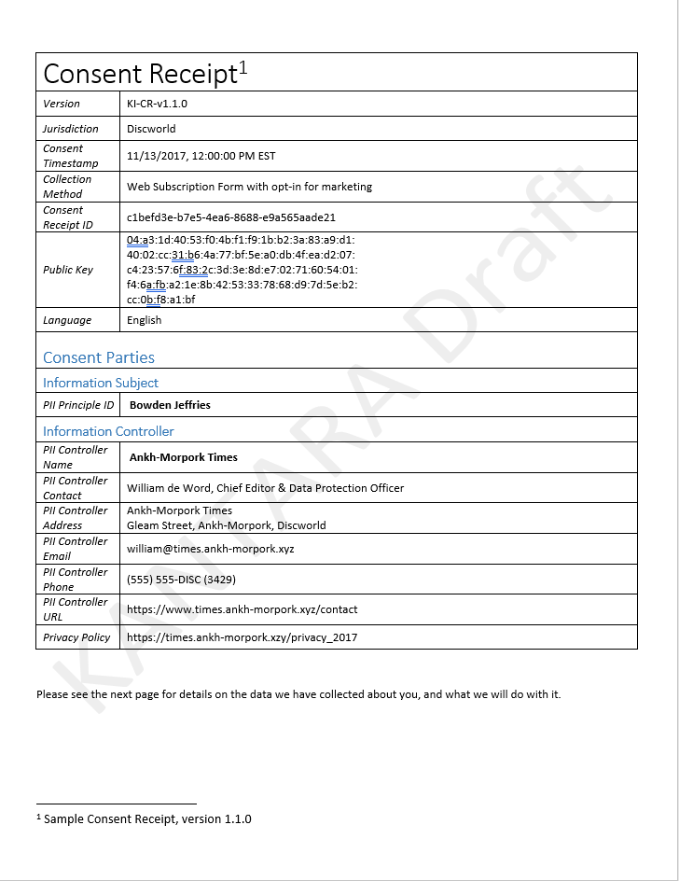
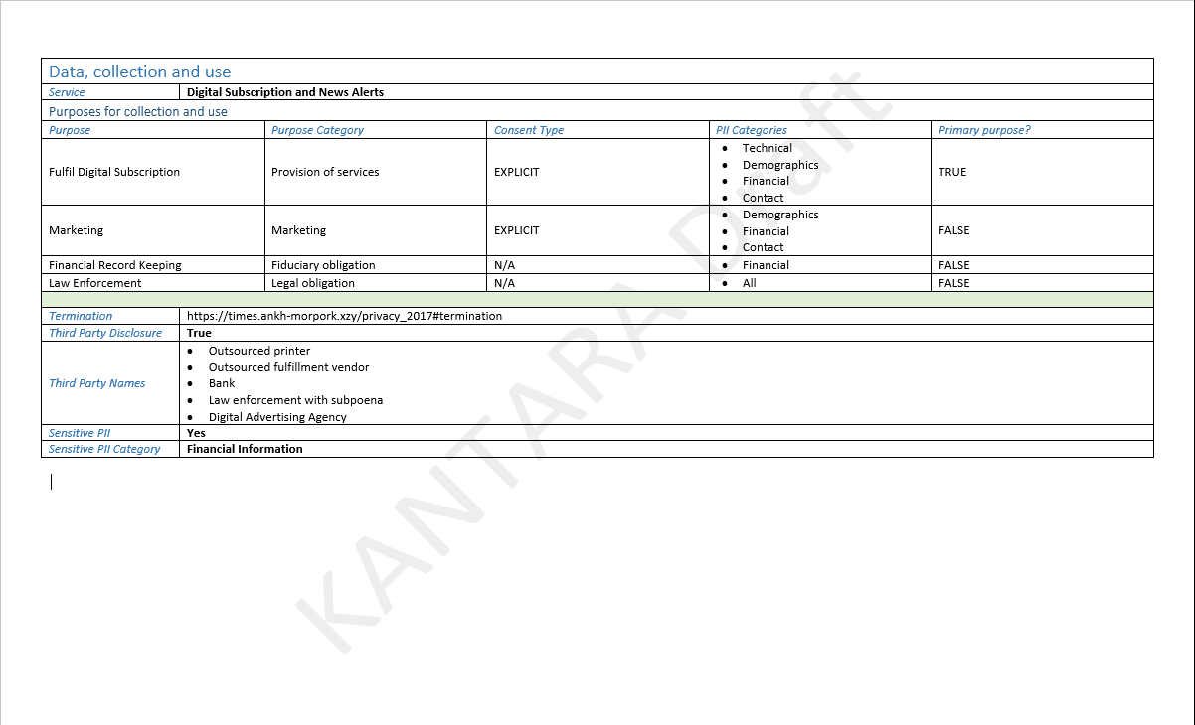

- Human-readable Consent Receipt – Fancy
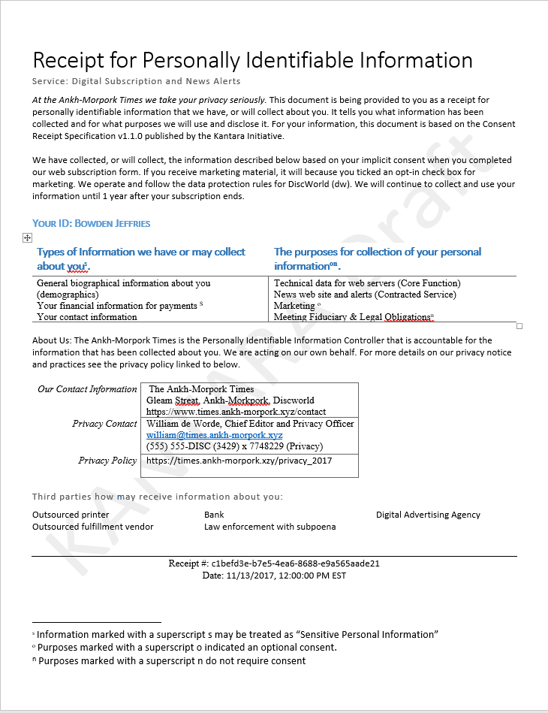
- JSON Consent Receipt
{
"version": "KI-CR-v1.1.0",
"jurisdiction": "DW",
"consentTimestamp": 1510592400,
"collectionMethod": "Web Subscription Form with opt-in for marketing",
"consentReceiptID": "c1befd3e-b7e5-4ea6-8688-e9a565aade21",
"publicKey": "04:a3:1d:40:53:f0:4b:f1:f9:1b:b2:3a:83:a9:d1:\r\n40:02:cc:31:b6:4a:77:bf:5e:a0:db:4f:ea:d2:07:\r\nc4:23:57:6f:83:2c:3d:3e:8d:e7:02:71:60:54:01:\r\nf4:6a:fb:a2:1e:8b:42:53:33:78:68:d9:7d:5e:b2:\r\ncc:0b:f8:a1:bf",
"language": "en",
"piiPrincipalId": "Bowden Jeffries",
"piiControllers": [
{
"piiController": "Ankh-Morpork Times",
"contact": "William De Worde",
"address": {
"streetAddress": "Gleam Street",
"addressCountry": "DW"
},
"email": "william@times.ankh-morpork.xyz",
"phone": "(555) 555-DISC (3429)"
}
],
"policyUrl": "https://times.ankh-morpork.xzy/privacy_2017",
"services": [
{
"service": "Digital Subscription and News Alerts",
"purposes": [
{
"purpose": "To provide contracted services",
"purposeCategory": [
"2 - Contracted Service"
],
"consentType": "EXPLICIT",
"piiCategory": [
"1 - Biographical",
"2 - Contact",
"4 - Communications/Social",
"7 - Financial"
],
"primaryPurpose": true,
"termination": "Subscription end date + 1 year",
"thirdPartyDisclosure": true,
"thirdPartyName": "The Ankh-morpork Deadbeat Debt Collectors Society"
},
{
"purpose": "To personalize service experience",
"purposeCategory": [
"5 - Personalize Experience"
],
"consentType": "EXPLICIT",
"piiCategory": [
"1 - Biographical",
"2 - Contact",
"4 - Communications/Social"
],
"primaryPurpose": false,
"termination": "Subscription end date + 1 year",
"thirdPartyDisclosure": false
},
{
"purpose": "To market services",
"purposeCategory": [
"6 - Marketing"
],
"consentType": "EXPLICIT",
"piiCategory": [
"2 - Contact"
],
"primaryPurpose": false,
"termination": "Subscription end date + 1 year",
"thirdPartyDisclosure": false,
"thirdPartyName": "DiscWorld Octarine Programmatic Ad Agency"
},
{
"purpose": "Complying with legal obligations",
"purposeCategory": [
"12 - Legally Required Data Retention",
"13 - Required by Law Enforcement or Government"
],
"consentType": "N/A",
"piiCategory": [
"1 - Biographical",
"2 - Contact",
"4 - Communications/Social",
"7 - Financial"
],
"primaryPurpose": false,
"termination": "N/A",
"thirdPartyDisclosure": true,
"thirdPartyName": "Requesting legal authority"
}
]
}
],
"sensitive": true,
"spiCat": [
"1 - Biographical",
"7 - Financial"
]
}

Revision history
Version | Date | Summary of Substantive Changes
1.1.0 DRAFT 1 | 2017-02-28 | Initial v1.1 draft
1.1.0 DRAFT 2 | 2017-07-12 | Sprint 2 draft.
1.1.0 DRAFT 3 | 2017-08-23 | Sprint 3 draft
1.1.0 DRAFT 4 | 2017-10-19 | Roll up of Sprint 4 – Sprint 6
1.1.0 DRAFT 5 | 2017-10-25 | Major reorg of document.
1.1.0 DRAFT 6 | 2017-11-17 | Final revisions and updates to the document.

