Digital Catapult Centre
  - Personal Data Receipt
<digitialcatapultcentre.org.uk>

The following show the human readable receipt itself and the email in which it was embedded, received about two hours after receiving a contract after signing in at a physical space.
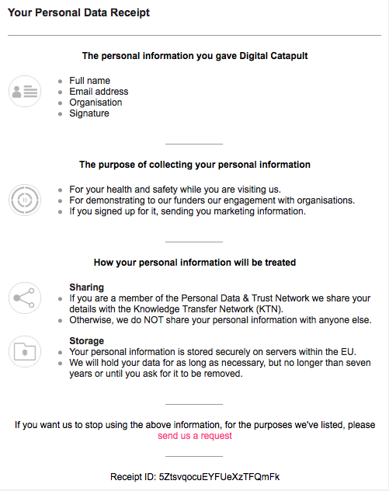
Figure 1 Human Readable Receipt sent via email
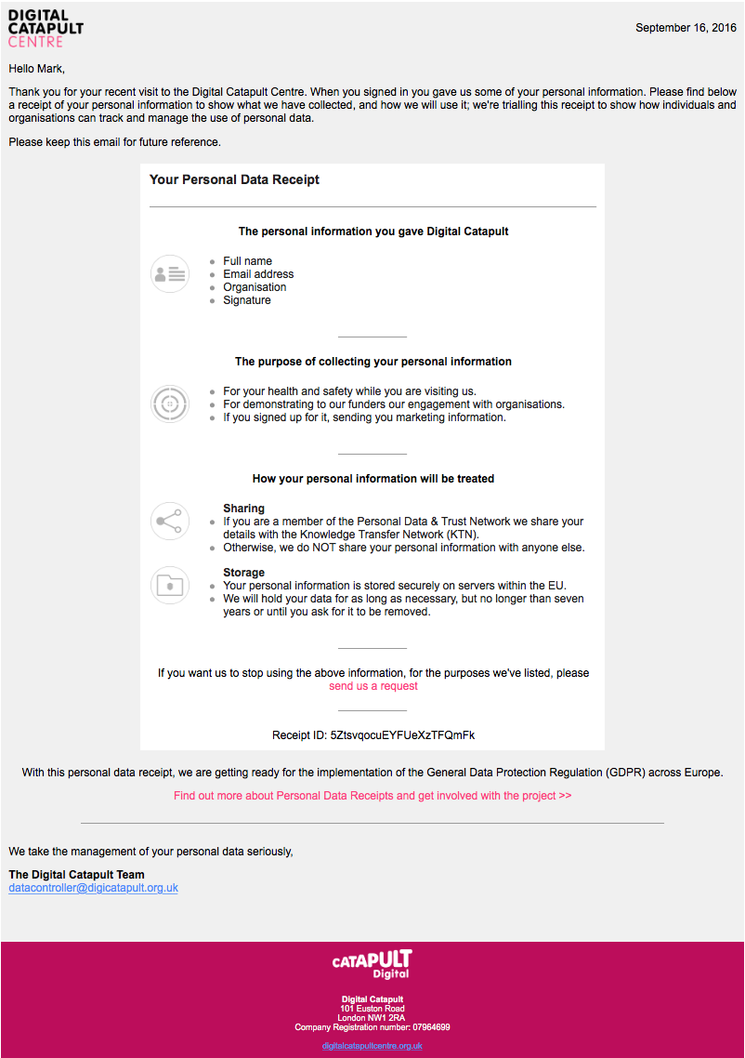
Figure 2 Full body of email containing human readable receipt

