Backend Identity Data Exchange framework

Version 0.2

Revision History
Date | Version | Description | Author
15/11/2011 | 0.1 | Initial draft | Venkat Maddali
22/11/2011 | 0.2 | Feedback from igovt enterprise architect incorporated | Venkat Maddali

Document Approval

Prepared by | Signature | Date
Venkat Maddali
Solutions Architect
Government Technology Services
Department of Internal Affairs

Approved by | Signature | Date
Steffen Sorenson
Enterprise Architect
Government Technology Services
Department of Internal Affairs

Table of Contents
1. Introduction 4
1.1 Purpose 4
1.2 Audience 4
1.3 Assumptions 4
1.4 Glossary of terms 5
2. BIDE Framework - Logical Views 6
2.1 The user initiates a transaction directly from the frontend service agency – pull & push patterns 7
2.2 The user initiates a transaction via a third party service – pull pattern 9
2.3 The user initiates a transaction via a third party service – push pattern 11
2.4 User offline – transaction initiated from frontend service agency 13
2.5 User offline – transaction initiated from third party service 15
2.6 Overview of Tokens Used 16
3. Core Responsibilities of the Frontend service agency 17

Introduction

Where business processes at one service agency require verified authoritative personal information from other services agencies, the information must be exchanged in a manner that ensures security and privacy, and must only be done at the request or with consent of the individual that the information concerns.

To achieve this goal, the Backend Identity Data Exchange (BIDE) framework has been developed to provide patterns for exchanging messages about identity in a secure and privacy protected manner.

Purpose

The purpose of this document is to provide a high level overview of the message exchange patterns which comprise the Backend Identity Data Exchange (BIDE) framework.
Audience
This document is intended for enterprise architects, solution architects, technical mangers and technical consultants.

Assumptions
The paper is based on the following assumptions:

- The business trust and relationship must be established between the agencies prior to identity data exchanges.
- Agencies must integrate with the logon service
- The users must federate their identity information at various agencies using the logon service.
- User authentication via the logon service is at the appropriate strength (low or medium) to gain access to specific backend services.
- The framework has been developed in compliance with New Zealand privacy laws.

Glossary of terms

Term | Definition
Backend service | The backend service provides services to the frontend service agency, usually by having the ability to communicate with the resource required.
Context mapping service | The mapping is done by the context mapping service issuing a token, representing the user, which can only be read by the context mapping service. The token is passed to the source service provider, which passes it on to the target service provider, who then passes it back to the context mapping service for validation.
FLT | Federated logon token issued by the logon service for individual users to each service provider. Also referred to as a persistent pseudonymous reference.
Frontend service agency | The frontend service agency is responsible for authenticating the user and providing a platform for the user to transact with other service government agencies.
Logon service | A shared government service used to authenticate the user at any government agency.
PIM Service | Personal information management service.
SAML | Security Assertion Markup Language is an OASIS standard that defines a framework for exchanging security assertions (described in XML) between online partners.
Secure Token Service (STS) | See context mapping service
Service agency | Service provider integrated in the BIDE framework

BIDE Framework - Logical Views
The frontend service agency provides a platform for the user to transact with other government agencies. Typically these government agencies will expose their services as backend services to the frontend service agency, so that the user can view and update their details via the frontend service agency application.

Note: The backend services must be identity aware to process the requests.

BIDE Framework Patterns

The BIDE framework has established the following patterns for initiating interaction between the frontend service agency and the backend services:

- The user initiates a transaction directly from the frontend service agency
- The user initiates a transaction via a third party service
- The user is off-line (not interacting with the frontend service agency)

The BIDE framework includes the following message exchange patterns between the frontend service agency and the backend services:

- Pull pattern: The frontend service agency retrieves identity information from backend services.
- Push patterns:
  - New user pattern: The frontend service agency captures user information and pushes the information to backend services. On receiving information the backend services may register the user or kick off their own evidence of identity (EOI) process.
  - Existing user pattern: The frontend service agency captures updates on behalf of the backend services and pushes the updated identity information to backend services.
  - Auto federation pattern: The backend service already holds the identity details and has not federated the user previously. The backend service is not required to integrate with the logon service directly for the user authentication. Instead the backend service utilises the frontend service agency platform for the user authentication. That is, on receiving the user authentication context from the frontend service agency, the backend services will federate the existing user identity information using the context mapping service.

The user initiates a transaction directly from the frontend service agency – pull & push patterns

Figure 1 provides a high level view of the user interacting directly with the frontend service agency which acts as intermediary for either pulling or pushing information from the backend services.

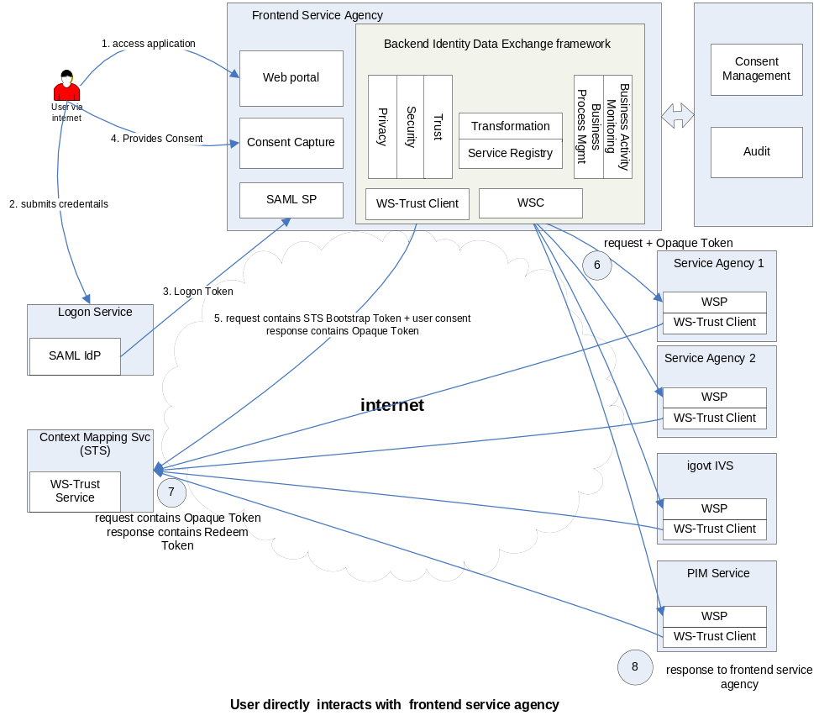

Figure 1: User interacts directly with frontend service agency

The steps in Figure 1 are summarised below:

- The user accesses the frontend service agency application directly.
- The user is redirected to the logon service for authentication. The user submits their credentials.
- The logon service returns a logon token to the frontend service agency.
- The user transacts at the agency and requires either pulling or pushing user information from the backend services. The user provides consent to these transactions.
- The frontend service agency asks the context mapping service for a token for that user for each of the required backend services.
- The frontend service agency makes a request to the backend services and passes the token from step 5.
- The backend service asks the context mapping service to validate the token. The context mapping service issues a validated token for the user at each required backend service.
- The backend service validates the user token, processes the request and returns the response to the frontend service agency.

The user initiates a transaction via a third party service – pull pattern

Figure 2 provides a high level view of the user interacting with a third party service and the frontend service agency acts as an intermediary for pulling user information from the backend services.

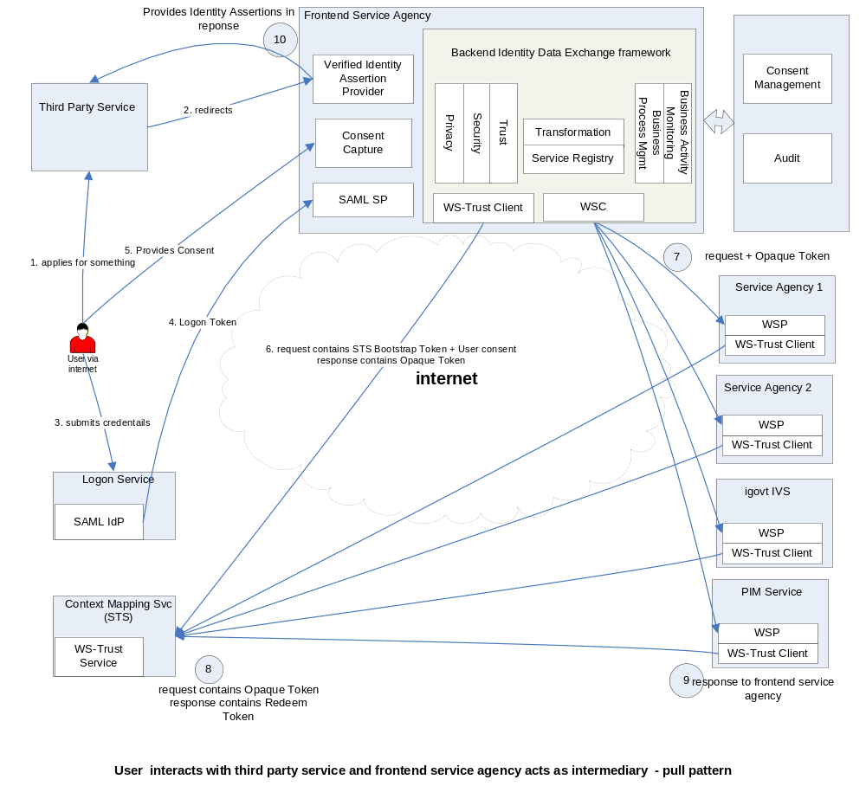
Figure 2: User initiates a transaction via a third party service – pull pattern

The steps in Figure 2 are summarised below:

- The user accesses the third party service and applies for entitlements or registers to the third party service. The agency requires pulling user information from the backend services.
- The user is redirected to the frontend service agency.
- The user is sent to logon service for authentication. The user submits their credentials.
- The logon service returns the logon token to the frontend service agency.
- The user provides consent to the transaction involving backend services.
- The frontend service agency asks the context mapping service for a token for that user for each of the required backend services.
- The frontend service agency makes a request for pulling user information to the backend services and passes the token from step 6.
- The backend service asks the context mapping service to validate the token. The context mapping service issues a validated token for the user each of the required backend services.
- The backend service validates the user token, processes the request and returns the response to the frontend service agency.
- The frontend service agency builds identity assertions based on the response from the backend services and returns these assertions to the third party service.

The user initiates a transaction via a third party service – push pattern

Figure 3 provides a high level view of the user interacting with a third party service and the frontend service agency acts as intermediary for pushing user information from the backend services.

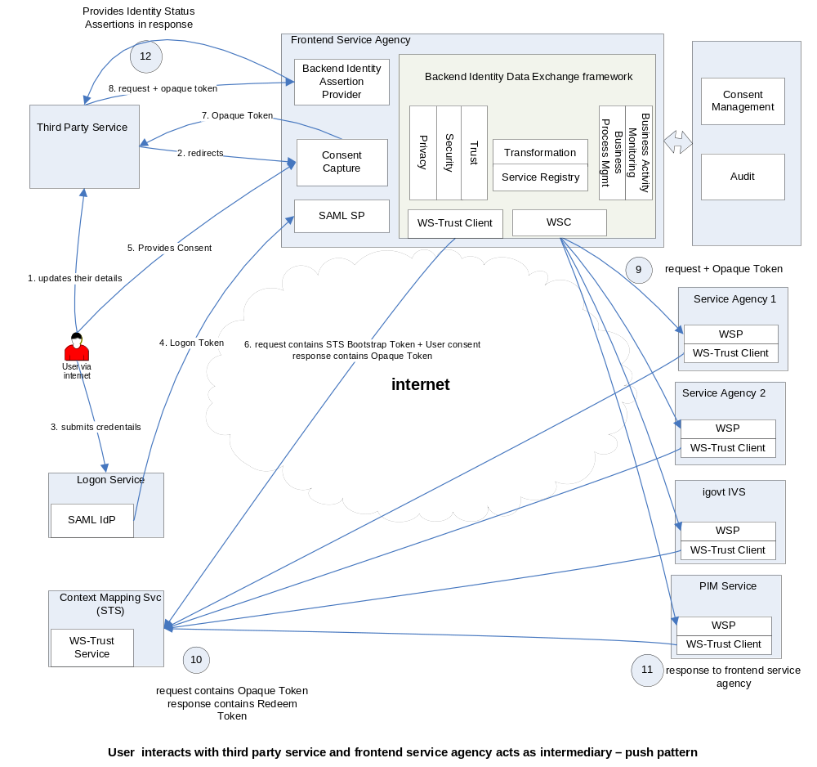
Figure 3: User initiates a transaction via third party service – push pattern
The steps in Figure 3 are summarised below:

- The user accesses the third party service and updates their details which require pushing user information to the backend services.
- The user is redirected to the frontend service agency.
- The user is sent to logon service for authentication. The user submits their credentials.
- The logon service returns the logon token to the frontend service agency.
- The user provides consent to the transaction involving backend services.
- The frontend service agency asks the context mapping service for a token for that user for each of the required backend services.
- The frontend service agency returns a response with an opaque token to the third party service.
- The third party service makes a backend request to the frontend service agency for pushing user information to the backend services and passes the opaque token in the request.
- The frontend service agency routes the request and the token to the required backend services.
- The backend service asks the context mapping service to validate the token. The context mapping service issues a validated token for the user at each required backend service.
- The backend service validates the user token, processes the request and returns the response to the frontend service agency.
- The frontend service agency builds identity status assertions based on the response from backend services and returns these assertions to the third party service.

User offline – transaction initiated from frontend service agency

Certain business transactions may occur when the user is offline and may have been triggered based on the user’s online activity at the frontend service agency or the third party service. These transactions still require user consent. The frontend service agency must capture this while the user is online and persist the consent even if the user is offline. To achieve this, the frontend service agency must use a consent management service.

Figure 4 provides a high level view of frontend service agency directly pulling or pushing user information from backend services when the user is offline.

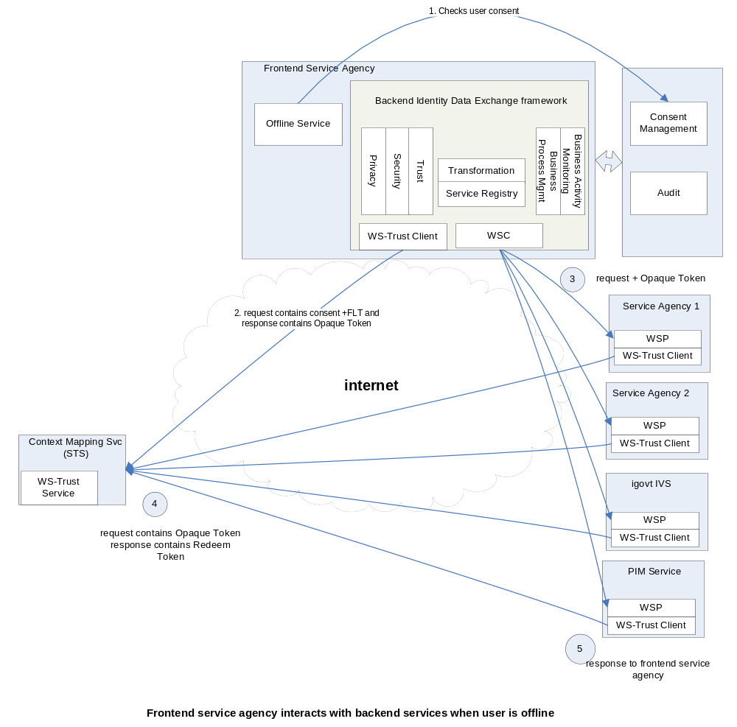
Figure 4: User offline transaction initiated by frontend service agency

The steps in Figure 4 are summarised below:

- The offline service at the frontend service agency checks with the consent management service for the user’s consent for offline transactions.
- The frontend service agency asks context mapping service for token for that user for each of the required backend services.
- The frontend service agency makes a request for either pulling or pushing user information to the backend services and passes the token from step 2.
- The backend service asks the context mapping service to validate the token. The context mapping service issues a validated token for the user at each required backend service.
- The backend service validates the user token and processes the request and returns the response to the frontend service agency.

User offline – transaction initiated from third party service

Figure 5 provides a high level view of third party service interacting with the frontend service agency which acts as intermediary for either pulling or pushing user information from backend services when the user is offline.

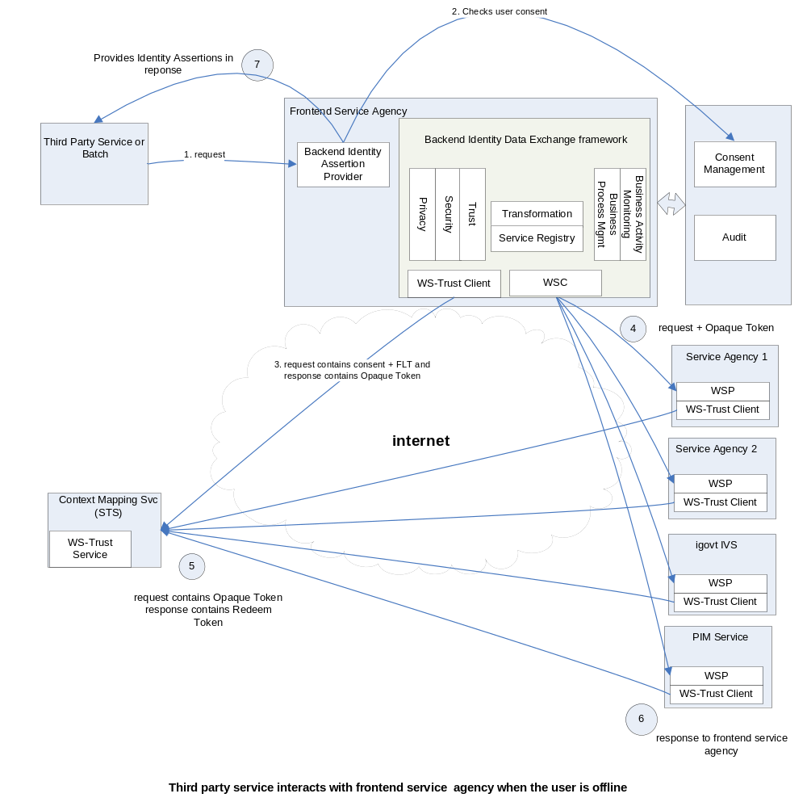
Figure 5: User offline transactions initiated by third party service

- The third party service requests a transaction.
- The offline service at the frontend service agency checks with the consent management service for the user’s consent for offline transactions.
- The frontend service agency asks context mapping service for token for that user for each of the required backend services.
- The frontend service agency makes a request for either pulling or pushing user information to the backend services and passes the token from step 2.
- The backend service asks the context mapping service to validate the token. The context mapping service issues a validated token for the user at each required backend service.
- The backend service validates the user token and processes the request and returns the response to the frontend service agency.
- The frontend service agency returns identity assertions to the third party service.

Overview of Tokens Used
The following table describes the tokens issued as shown in Figure 1 and Figure 2:

Token | Issued By | To Whom | FLT belongs to | Other content
 |  |  |  | User online trans. | User offline trans.
Logon Token | Logon service | Frontend service agency | Frontend service agency | Authentication Strength, Authentication Time  Token expiry period | NA
STS Bootstrap Token | Logon Service, as an attribute in Logon Token | Frontend service agency, the agency sends this token to STS to obtain Opaque token for backend service | Frontend service agency | Authentication Strength, Authentication Time  Token expiry period | NA
Opaque Token | Context mapping STS | Frontend service agency, this token will be passed to backend services to identify the user. | Encrypted | Authentication Strength, Authentication Time  Token expiry period | Token expiry period
Redeem Token | Context mapping STS | Backend service | Backend Service | Authentication Strength, Authentication Time  Token expiry period | Token expiry period
Table 1: Token descriptions

Core Responsibilities of the Frontend service agency

The following summarises the core responsibilities (functional and non-functional) of the frontend service agency:

- Authentication: must integrate with the logon service to authenticate the user. Also required to integrate with context mapping service to extend user authentication from their context to the backend services.
- Security:
  - Must have process and infrastructure in place to resist security attacks such as denial service attacks, phishing and penetration attempts etc.
  - Must provide a secure communication channel between users and the backend services.
  - Must exchange identity data in confidential manner with the backend services.
- Consent Capture/ Management: must capture the user consent for processing each transaction. The captured consent might require for some of transactions when is user is offline and is required to be persisted. If the consent is persisted then must manage the life cycle of all consents.
- Privacy: must include mechanisms to prevent unauthorised access or misuse of identity information.
- Transformation: require to convert messages that are understandable by the backend services to allow the frontend application and backend services to work together despite incompatible business applications, schemas etc.
- Service Registry: must maintain registry of backend services and their configurations including endpoint, schema, service policies etc.
- Business Process Management: Ideally employs methods, policies, metrics, and software tools to continuously optimize business processes, where a business process is defined as an activity, or set of activities, that accomplishes a specified goal.
- Business Activity Monitoring: Ideally employs technology to proactively define and analyze critical opportunities and risks in an enterprise to maximize profitability and optimize efficiency.
- Trust: Trust is key concept of BIDE framework. Must ensure direct trust with participating backend services by employing proper authentication mechanisms and message integrity checks. Secure channels must be established to provide confidence about the information being exchanged.
- Non-repudiation: must support non-repudiation for transactions, where required it to mitigate the risk of transacting parties later denying having participated in a transaction. The following must be in place to ensure non-repudiation:
  - Message signing
  - Message encryption
  - Secure audit logs
  - Secure timestamps
  - Transport layer security
Note: Non repudiation significantly contributes to business trust.
- Standards: require support of open standards. The BIDE framework is based on open standards such as WS-*, SAML2.0 etc. This ensures a low technology barrier for participation in the BIDE framework via deployment of backend services.
- Transaction History: must provide a facility for the user to view their past transaction history including audit records of all information released through BIDE framework.

